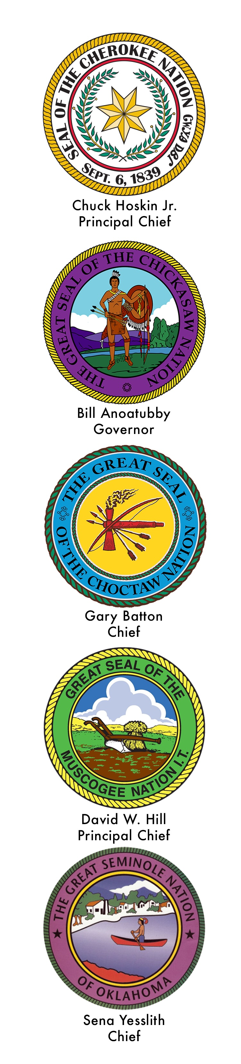
The INTER-TRIBAL COUNCIL
of the FIVE CIVILIZED TRIBES
organized February 3, 1950

