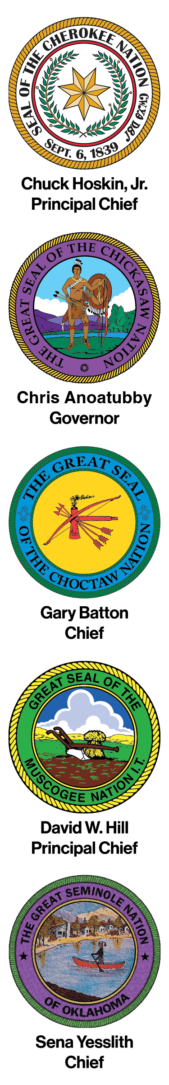
A Resolution Supporting

Resolution No. 25-
WHEREAS, the Inter-Tribal Council of the Five Civilized Tribes (ITC) is an organization that unites the tribal governments of the Cherokee, Chickasaw, Choctaw, Muscogee (Creek) and Seminole Nation, representing approximately 877,000 Indian people throughout the United States; and
WHEREAS, ; and
WHEREAS, ; and
NOW THEREFORE LET IT BE RESOLVED THAT, the Inter-Tribal Council of the Five Civilized Tribes.
BE IT FURTHER RESOLVED, the Inter-Tribal Council of the Five Civilized Tribes.

CERTIFICATION
The foregoing resolution was adopted by the Inter-Tribal Council of the Five Civilized Tribes meeting in Durant, Oklahoma on this ___ day of ________, 2026, by a vote of ___________ for __________ against and ______ abstentions.

_______________________________ __________________________________
Chris Anoatubby, Governor David W. Hill, Principal Chief
The Chickasaw Nation Muscogee (Creek) Nation

________________________________ ___________________________________
Gary Batton, Chief Chuck Hoskin Jr., Principal Chief
Choctaw Nation of Oklahoma Cherokee Nation

________________________________
Sena Yesslith, Chief
Seminole Nation of Oklahoma

