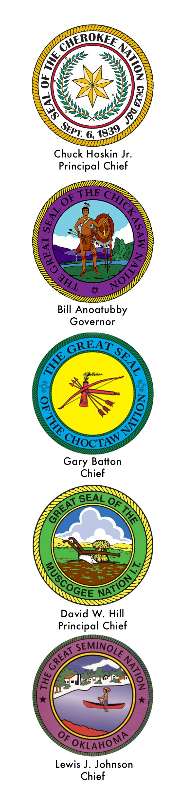

**The INTER-TRIBAL COUNCIL**

**of the FIVE CIVILIZED TRIBES**

organized February 3, 1950